**Review on Advance Street Light System using IoT**

Lalit Makar1#, Vrushali Patil2#, Khusboo Patel3#, *Priti Rumao4 # =Equal Contribution

## 1,2,3(Computer Engineering, Atharva College of Engineering/Mumbai University, India)

*\*4( Prof. ,CMPN, Atharva College of Engineering/Mumbai*

*University, India)*

[*1lalitmakar71@gmail.com*](mailto:1lalitmakar71@gmail.com) *, 2*[*vrushalipatil095@gmail.com*](mailto:vrushalipatil095@gmail.com) *,* [*3kkp5601@gmail.com*](mailto:3kkp5601@gmail.com)

*\*4*[*pritirumao@gmail.com*](mailto:pritirumao@gmail.com)

**Abstract**

*The existing system is manually controlled and has flaws such as high energy consumption, high maintenance, high cost and lack of efficient monitoring system. The system proposed in this paper helps in cutting down the unnecessary energy that is consumed by street lights. This goal is achieved by changing the intensity of street lights as per external environment. When an object is detected on the road by the ultrasonic sensor the lights will glow at maximum intensity and will get back to 25-30% intensity otherwise. Also this system includes Wi-Fi based micro-controller NodeMCU to send alert notification to the authorities in case of faulty street lights.*

***Keywords:*** *IoT, Power saving, LDR, LED, NodeMCU, movement detection, intensity control.*

# Introduction

Street lights are an important factor in modern cities. Conventional street lights consume enormous electric energy. The main motive of the proposed system is to conserve this electrical energy utilized by the street lights. This saved energy can be used for many other applications. Large areas can be illuminated with high intensity when required with the help of LED that does not require huge amount of electricity. Street lights are a crucial part of a city’s infrastructure accounting for 30-50% of total energy bill worldwide. They are necessary for security reasons of pedestrians, vehicles etc. during the night. To overcome issues such as high power consumption and high maintenance cost the proposed system makes use of ultrasonic sensors, LDRs and low-cost micro-controller to automatically switch off lights during day. During the night if the ultrasonic sensor detects an object such as a vehicle, human, animal etc. lights will start glowing at maximum intensity. In other cases, they will glow at comparatively lower intensity. It also consists of a fault detection module which uses the internet to automatically send an alert message to the authorities about faulty street lights. Making use of such energy efficient technology reduces cost to a great extent.

# Literature Review

*Kavita A. Bajaj, Tushar S. Mote* [1] proposes a highly efficient centralized street light system which concentrates on three main areas. Firstly, they use light emitting diode (LED) instead of sodium vapor lamps and Compact fluorescent lamp (CFL) for long life and power saving features. Secondly, point-to-point information transfer is done using ZigBee transmitters and receivers. This information is sent to the control terminal to check the status of the street lights and take necessary actions in case of any failure. Thirdly, renewable energy sources such as solar energy to achieve maximum efficiency. Lights are switched ON/OFF automatically with the help of LDR status and the value of the PIR sensor. The status information of the street lights is stored in the PIC controller.

*Kunjal Nanavati et.al* [2] developed a system with four modules namely: 1. Solar Tracking System: It consists of a solar plate with a servo motor which rotates the solar panels as per the position of the sun and stores the power into the battery. 2. Auto Dimming: This feature enables the led to glow with low power when the light intensity is high and glow with high power when the light intensity is low i.e the LEDs glow with high intensity during the night and with low intensity during the day. This was done using opt coupler.3.Fault Detection: Dual-band GSM/GPRS module was used which communicated with the controllers via AT commands. When there was a break down in the system the GSM was used to send an SMS to the control system regarding the same.

4. Auto Switching: It consisted of Relay, MAX 232 IC. During low power level of the battery the power automatically switches to grid power. The LDR was used to decide whether it is day time or night time by the intensity of the LDR. Due to this there is no manual operation.

*Aman Singhal* [3] explains a system to save maximum energy possible by avoiding inefficient lighting which wastes significant financial resources each year. This is done by dimming of lights when there is no vehicle present on the road i.e. lights are at minimum intensity. When PIR sensor detects any movements the intensity of the lights is maximized and once the vehicle moves ahead of that region the lights automatically go back to the dim mode i.e. low intensity. This helps is saving 80% of the energy per day.

Surabhi Gurav et.al [4] proposes a smart street light system which aims at reducing power consumption by varying the light intensity as the object is detected. The line-in- sight IR sensors detect the object and micro-controller changes intensity of lights. This system also incorporates a Solar power module which powers the street lights. This system doesn’t have any fault detection system.

Snehal Bhosale et.al [5] developed a system to improve the efficiency by automating the process of switching the street lights. It consists of a control system, internet, electrical devices and a client server mechanism. With the help of this the user can directly interact with the Web based application to control the street lights.When user switches on the street light the server sends a notification to the controller to which decodes and finds the street light which has to be turned ON/OFF. The java application keeps a record of the entire street light of the city.

Vismita Kolvekar et.al [6] proposed an intelligent street light control system which uses two sensors namely LDR and the IR sensor and Raspberry Pi will act as brain to control this system. Street lights will be turned on when the object is detected at night otherwise it will be completely turned off, LDR will detect day/night and IR sensor will detect the object. Lights will be completely turned off when there is no vehicle detected.

# Existing System

Currently, within the whole world, enormous electric energy is consumed by the road lamps, which are automatically activate when it becomes dark and automatically close up when it becomes bright. This is the large waste of energy within the whole world and will be changed. Conventional street lights uses high intensity discharge lamps (HID), which leads to high energy consumption thus increasing demand and price for electricity. Due to high carbon emissions, climate changes occur. Also these lights have high maintenance cost, so we have to come up with a system that uses minimum power and also it should be environmentally friendly and cost effective.

Complications in Existing System:

* Lights gets completely on and off .So there is unnecessary wastage of power.
* No system for detection of faulty street lights.
* Existing system requires high maintenance.

1. **Comparison of Wireless technology:**

**Table 1.Comparison of wireless technology**

|  |  |  |  |
| --- | --- | --- | --- |
|  | **Zigbee** | **Bluetooth** | **Wi-Fi** |
| Data rate | 20,40,250 Kbps | 1Mbps | 11-54 Mbps |
| Security | 128-bit AES | 64 and 128 bit encryption | WEP,WPA,WPA2 |
| Range | 60m | 10m | 50-100m |

From table 1 we can infer that Bluetooth is unfit for this application due to its short range, while Zigbee offers less security. Wi-Fi is best suited as it provides high data rates and also provides the best security.

1. **Cost Analysis:**

**Table 2. Cost Analysis**

|  |  |  |  |  |
| --- | --- | --- | --- | --- |
| **Lamp type** | **No of columns** | **Maintenance cost** | **Installation cost/column** | **Energy(kWH)** |
| Sodium lamp | 52 | 560 | 500 | 237,700 |
| LED | 43 | 470 | 850 | 148,500 |

Table 2 shows the annual energy consumption. It also illustrates that the initial installation cost of Led’s is high but its maintenance cost is reduced as compared to sodium lamps. As per assumptions dimming control has the potential to save upto 6% of existing consumption, thus saving energy by replacing current street lights with Led.

1. **Proposed System**

The proposed system is an automated system designed to increase the efficiency as well as accuracy of an enterprise by automatically controlled switching of street lights. This is based on the light intensity in the vicinity. This project presents a new cost effective solution for street light system. The system architecture of our smart street light system is shown below (Fig.1) through a simplified block diagram. It consists of micro-controller module i.e NodeMCU which acts as the brain of the circuit. This proposed system also consists of different sensors for sensing various parameters.

* NodeMCU: NodeMCU as shown in fig.1 is a low-cost as well as an open source IoT platform. It includes firmware which runs on the ESP8166 Wi-Fi SoC and hardware which was based on the ESP-12 module. Also support for ESP32 32-bit MCU was added later.
* Light sensor (LDR):  LDR or light dependent resistors shown in fig.2 senses the presence of natural light in the surrounding as well as assists in automatic switching of LED’s that is the street light when it gets dark.
* Ultrasonic sensors: ultrasonic / level sensors shown in fig.3 measure distance by using ultrasonic waves. The sensor head emits an ultrasonic wave and receives the wave reflected back from the target at its receiver end. Ultrasonic / level sensors measure the distance between the sensor and the target by measuring the time taken between the emission and reception.

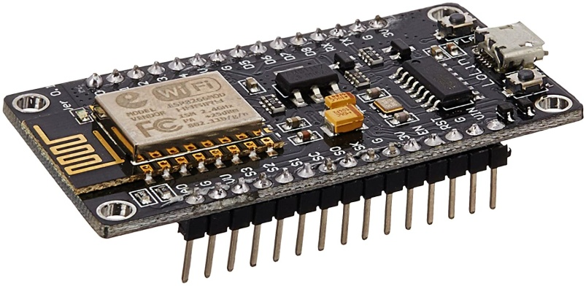

**Figure 1.NodeMCU**

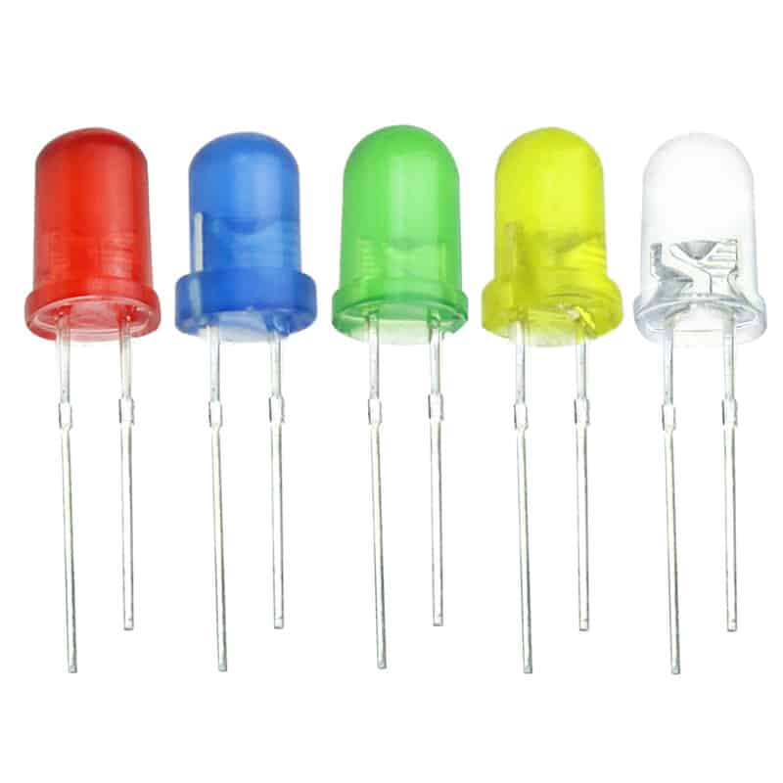

**Figure 2. LED**

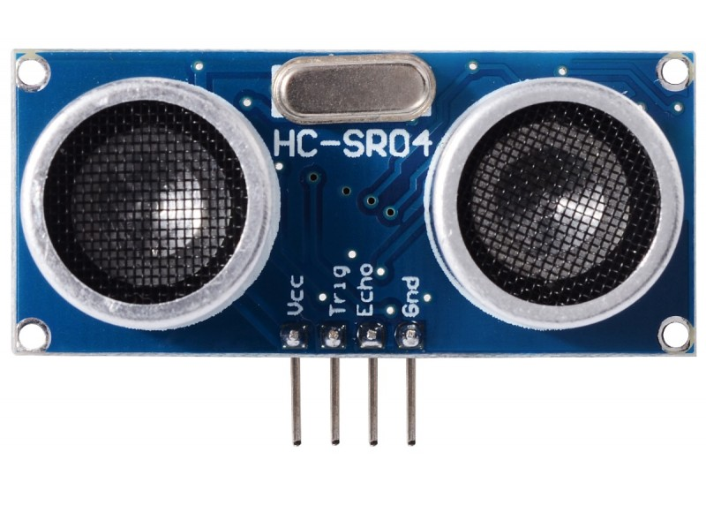

**Figure 3.Ultrasonic Sensor**

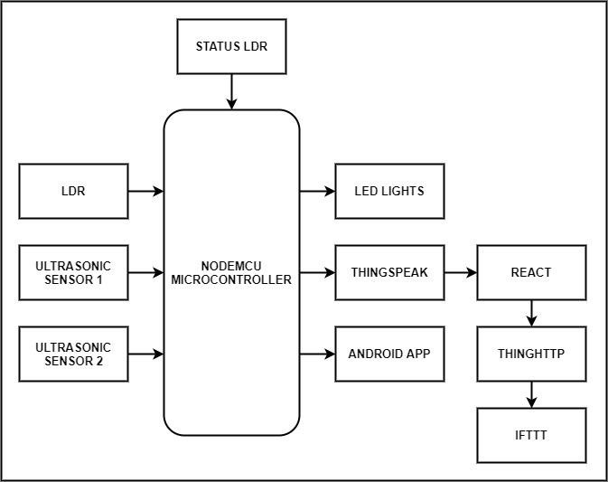

### Figure 4. Block Diagram

Features which are likely to be fulfilled by our proposed system are:

* Automatic switching/Dimming of street lights based on the surrounding light intensity.
* Automatic fault detection with the assistance of sensors.
* Intensity control of LED on detection of human or vehicle.
* Controlling and maintenance via wireless communication using built-in Wi-Fi module.

1. **Conclusion**

The crucial benefit of our project is power saving. This system will save tremendous amount of economy in the coming years. The project will be studied and designed using NodeMCU with built-in Wi-Fi module. This initiative will help us save energy and money. It will meet various other needs as well as develop our nation. In addition to this, another advantage it provides is less maintenance cost. This project is cost effective, pragmatic, practical and safe to travel at night time. The initial installation cost may be a disadvantage but with the bulk production of the module the overall cost can be reduced further as the project tenure graduates a certain amount. Due to the ability of sending automatic messages to the authorities, maintenance becomes easier. The proposed system is appropriate for street lighting in rural areas and specifically areas with low footfall count. The system is versatile, extendable and adjustable according to the needs of user.

# References

1. Kavita A. Bajaj, Tushar S. Mote "Review on Intelligent Street Lightening System", IJSR , Volume 4

,Issue 2, February 2015.

1. Kunjal Nanavati, Hemant Prajapati, Hemal Pandav, Krupali Umaria, Nilay Desai "Smart Autonomous Street Light Control System", IJSTE, Volume 2, Issue 10, April 2016.
2. Aman Singhal "Automatic Street Lights", IJAREM, Vol. 01, Issue 08, November 2015.
3. Surabhi Gurav, Hardik Rathod, Heta Shah Nilesh Rathod "Movement Sensing Street Lighting", IJRITCC, Volume: 6, Issue: 4, April 2018 .
4. Snehal Bhosale, Komal Gaware, Pradnya Phalke, Dipali Wadekar, Pallavi Ahire "Iot Based Dynamic Control Of Street Lights For Smart City", IRJET, Volume: 04, Issue: 05, May -2017.
5. Vismita Kolvekar, Valerie Vaz, Fatima Shaikh, Jyoti Kumari, Michelle Araujo E Viegas "Intelligent Automatic Street Light Control System", IJSRD, Vol. 4, Issue 11, May -2017.
6. Shagun Malhotra, Vivek Kumar “Smart Street Lighting System: An Energy Efficient Approach”, IJSR, Vol 5, February 2016.
7. Sankaran N, Arathy A, Arundhathy M, Revathy R, Athira M “A Comparative Approach of Energy Efficient Street Lighting Systems”, IJMTER, Vol 3, March 2016.
8. D Mondal, Rupali Diksha K, Shraddha K “Vehicle Movement using Street Light Detection”, IRJET, Vol 5, April 2018.
9. IRJET April 2018 Vol 5N Sivaiah, Lakshmi P, Tejaswini, Manisha, Yasaswini “Automated Street Light Controlling System”, IRJET, Vol 5, February 2018.